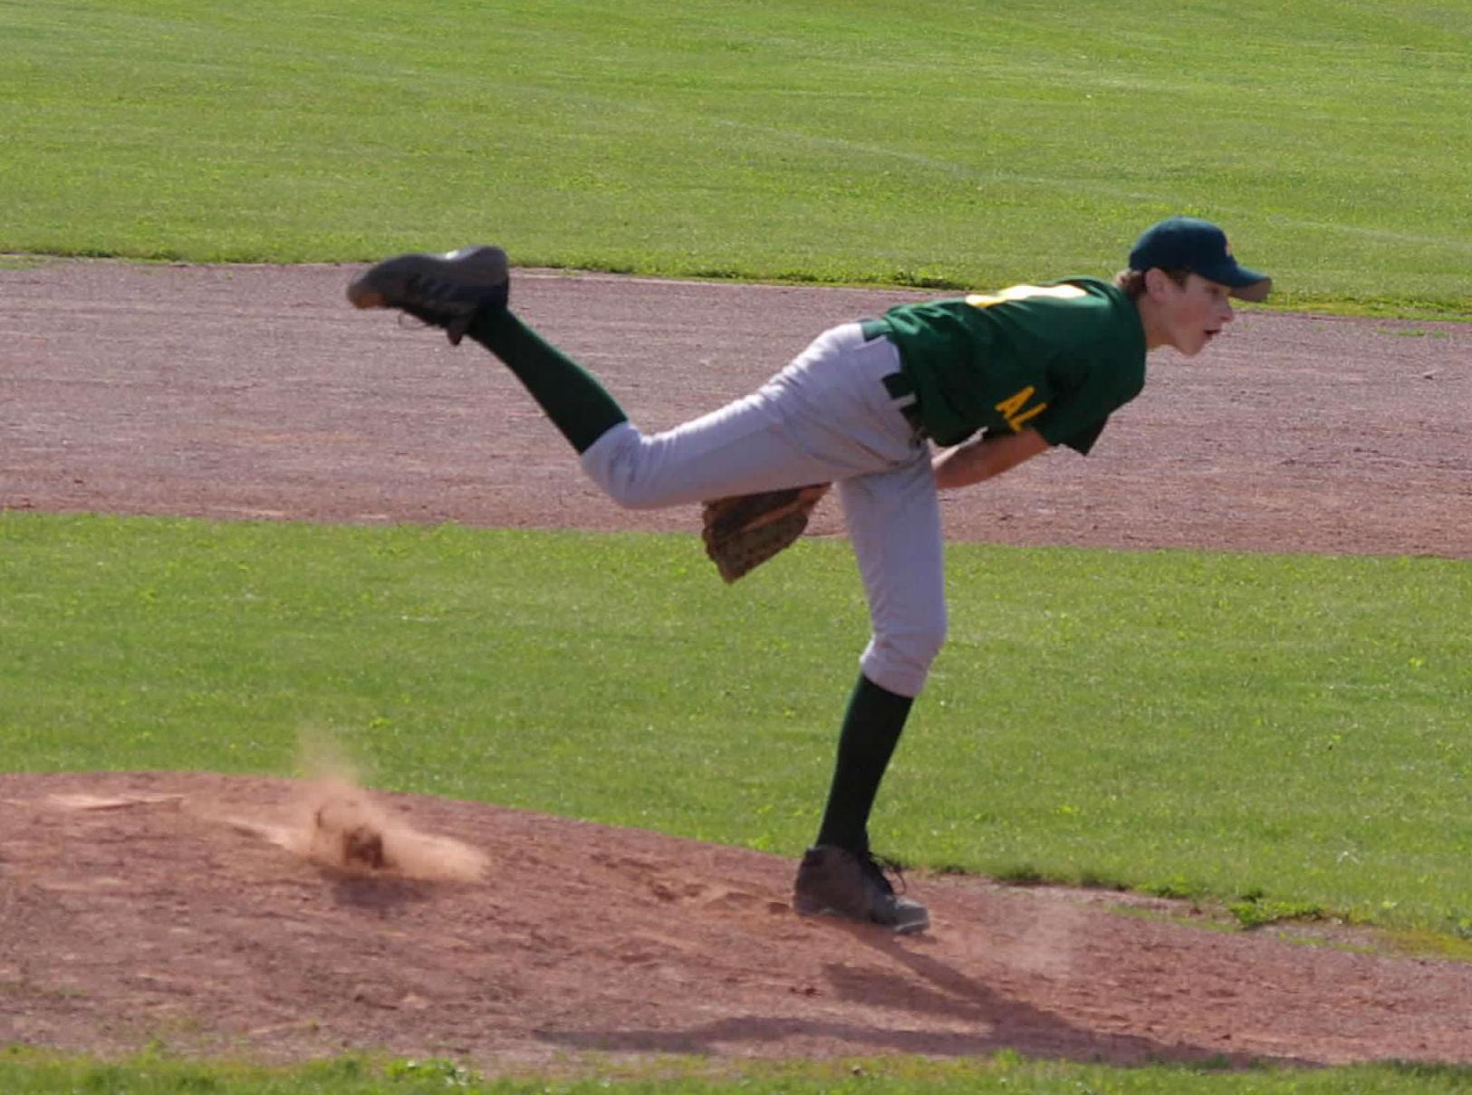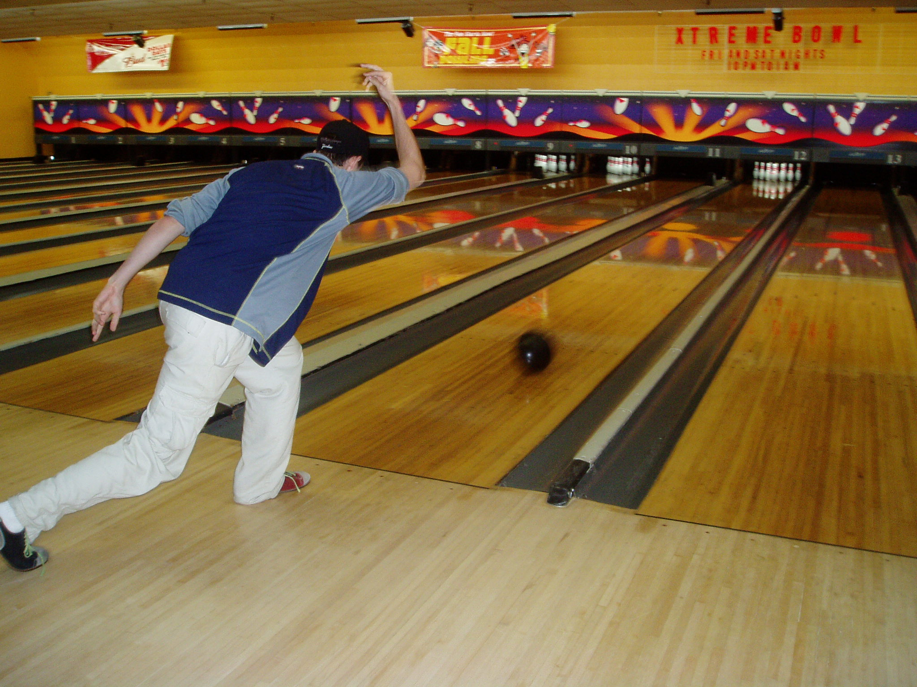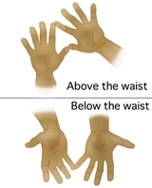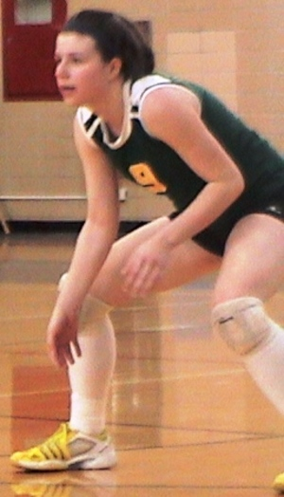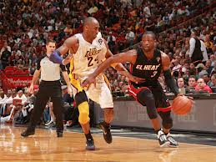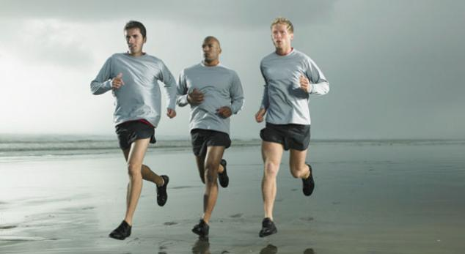

We assess Cardiovascular

Fitness by doing the Pacer Test and/or Mile Run.

## Assessment

Requires you to exercise

the body for long periods

of time (20 minutes minimum). During cardiovascular activity it is important to pace yourself.

This improves your heart health, increases energy levels, helps you to look and feel better. There are many ways to increase your cardiovascular endurance including jogging, biking and aerobics

## Cardiovascular Fitness

## Taking your pulse

2 most common places are your neck and wrist

The continuing action of the body after release or striking an object (such as throwing a ball). This is the ending action of throwing, hitting or kicking

A plan while playing a game.

## Follow Through

## Strategy

When catching a projectile (football, basketball, etc.) the receivers hands should be in the proper position to secure the projectile. A catch made up above the shoulders has the fingers pointing upward. A catch made below the waist has the fingers pointing downward.

## Catching Skills

An athletic stance with the knees bent and the feet shoulder width apart. It is used in nearly every sport.

## Ready Position

When performing a throwing or striking action, the opposite foot will be forward of the throwing/striking hand. Example right handed thrower should step forward with his/her left foot.

Offense—

The team that has possession of the ball

OR

The team trying to score points

Defense—

The team that does NOT have the ball

OR

The team trying to stop the opponent from scoring

## Team Sports

## Rule of Opposition

**Physical Education Philosophy—**

**WE BELIEVE,**

Participation is more important than winning.

Everyone’s safety is a top priority at all times.

All students should put forth their best effort.

All students should follow class and game rules.

Everyone should be a part of the action regardless of skill level.

New skills take time to develop and master.

All students should show good sportsmanship by participating in all activities, not just the ones they like.

All students should wear appropriate active wear for increased health, hygiene and safety.

Study

Text

Tri 1

# JMS Physical Education:

# Grade 6 Trimester 1 Study Text